Name: Omar ebraheem ahmed

B.N: 19

SEC: 23

ID:521

DATE: 4 Jun 2021

**Topic:- COVID19**

Github Link: [omarkhideer/html.project.report (github.com)](https://github.com/omarkhideer/html.project.report)

**Application brief:-** covid19 is Sickness of the Century so I write about it.

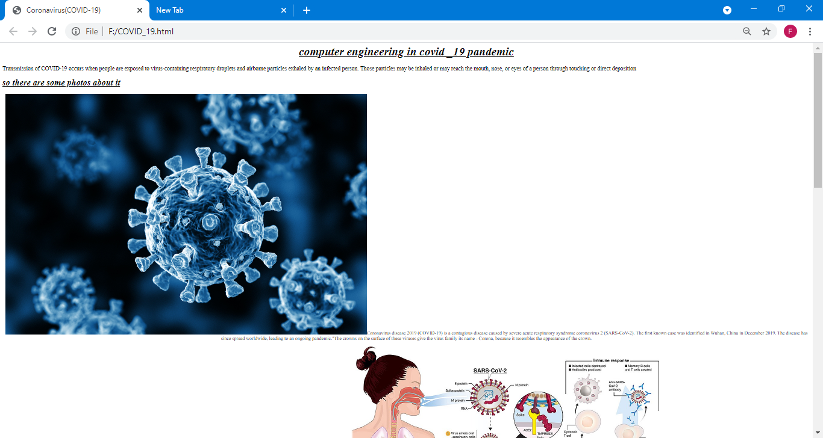**Screenshoots:-**

**Source Code:**

